Volume is inversely proportional to the pressure at a constant temperature. This is called
A. Charles’s law
B. Avogadro’s law
C. Dalton’s law
D. Boyle’s Law
ANSWER: D
The Boyle’s law gives ________ in a graph.
A. Straight line
B. Parabolic curve
C. Hyperbolic curve
D. All of them
ANSWER: B
The shape of the tube designed by Robert Boyle is
A. J-shaped
B. U-shaped
C. L-shaped
D. none
ANSWER: A
According to Boyle’s law, if pressure is doubled at constant temperature, volume will be _______________.
A. Increase to 4 times
B. Reduced to half
C. Doubled
D. Become zero
ANSWER: B
If the volume of gas is decreased at a constant temperature, the average velocity of the gas molecules remains _________.
A. Decrease
B. Increase
C. Zero
D. Constant
ANSWER: D
At constant temperature, in a given mass of an ideal gas
A. The ratio of pressure and volume always remains constant
B. Volume always remains constant
C. Pressure always remains constant
D. The product of pressure and volume always remains constant
ANSWER: D
Air at sea level is dense. This is a practical application of
A. Boyle's law
B. Charle's law
C. Avogadro's law
D. Dalton's law
ANSWER: A

Which of the following statement is false?
A. The product of pressure and volume of fixed amount of a gas is independent of temperature
B. Molecules of different gases have the same K.E. at a given temperature
C. The gas equation is not valid at high pressure and low temperature
D. The gas constant per molecule is known as Boltzmann constant
ANSWER: A
If P, V, T represent pressure, volume and temperature of the gas, the correct representation of Boyle's law is
A. V is inversely proportional to T(at constant P)
B. PV = RT
C. V inversely proportional to P(at constant T)
D. PV =nRT
ANSWER: C

Densities of two gases are in the ratio 1 : 2 and their temperatures are in the ratio 2 : 1, then the ratio of their respective pressures is
A. 1 : 1
B. 1 : 2
C. 2 : 1
D. 4 : 1
ANSWER: A

If pressure becomes double at the same absolute temperature on 2 L CO2, then the volume of CO2 becomes
A. 2 L
B. 4 L
C. 25 L
D. 1 L
ANSWER: B

Which of the following graph represents Boyle’s Law?
A. 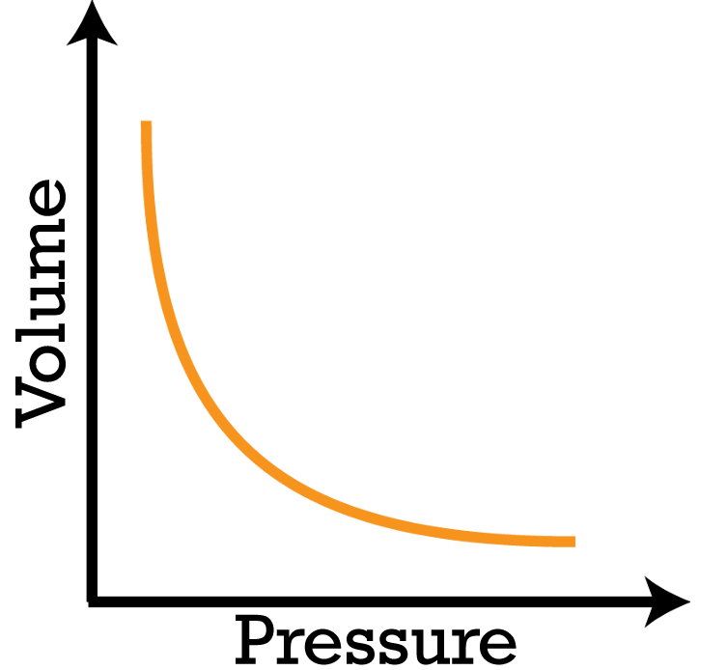
B. 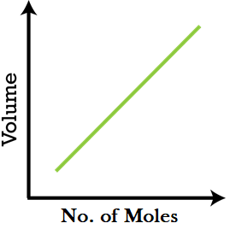
C. 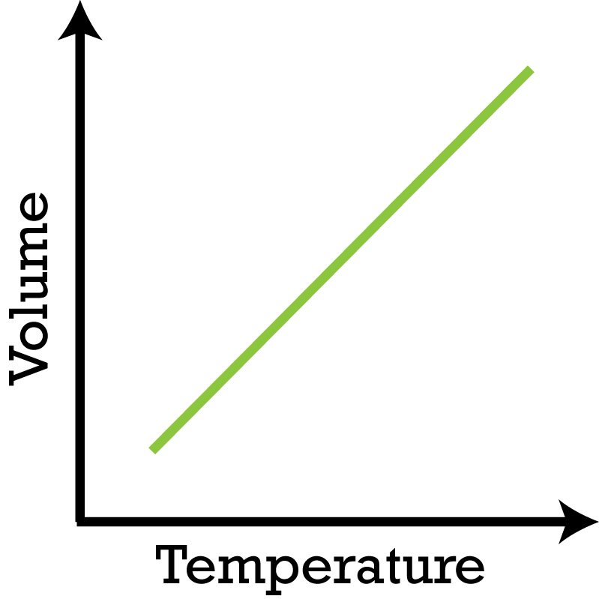
D. None of these
ANSWER: A
Let the pressure P and volume V for a certain gas. If the pressure is increased by 25% at a constant temperature, then what would be the volume of the gas?
A. 0.6V
B. 0.75V
C. 0.8V
D. 0.85V
ANSWER: C

What is the nature of the pressure-volume (P-V) graph in Boyle’s Law?
A. Straight Line;
B. Circle:
C. Elliptical;
D. Rectangular Hyperbola:
ANSWER: D

What is the nature of the pressure-volume vs Pressure (PV vs P) graph in Boyle’s Law?
A. Straight Line parallel to P axis
B. Straight line parallel to PV axis
C. Elliptical
D. Hyperbola
ANSWER: A

